TASKS ON LOAD BALANCER
- Configure Classic Load balancer.
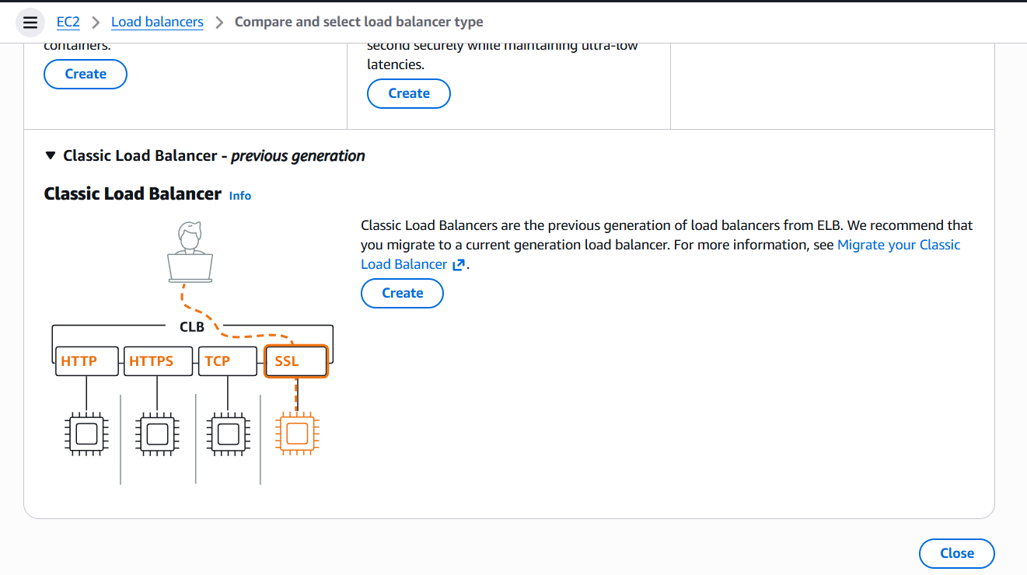
Create load balancerclassic-lbinternet-facingvpctwo subnetsdefault security group—listener&routing-health checkups—target group creating—we need to create 2 instancesvpc defaultsg defaultinstances added
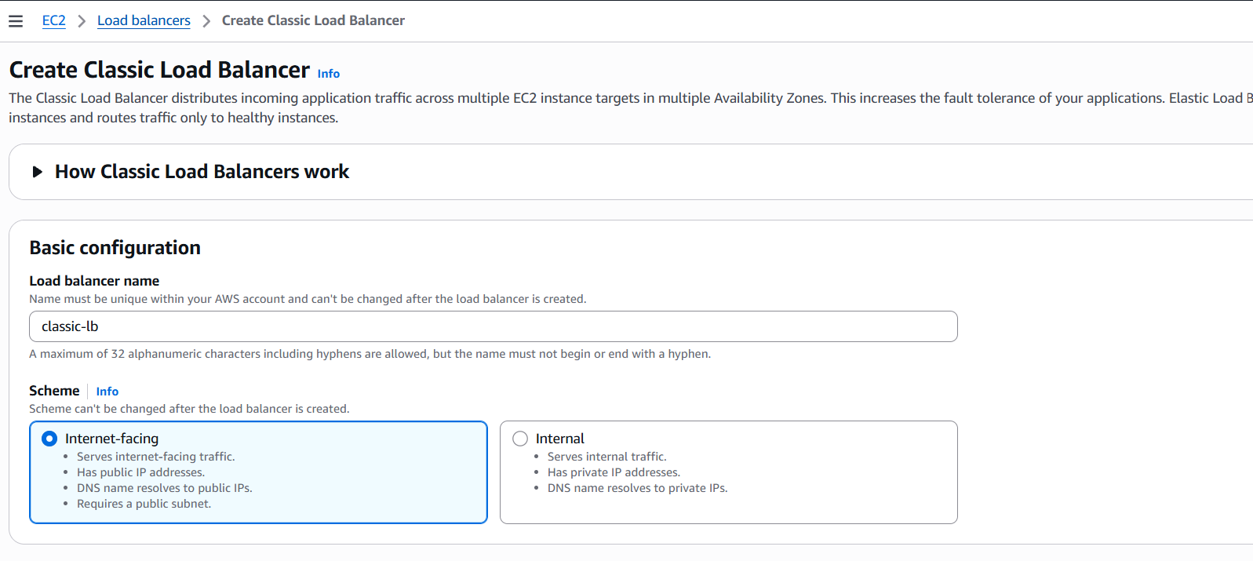
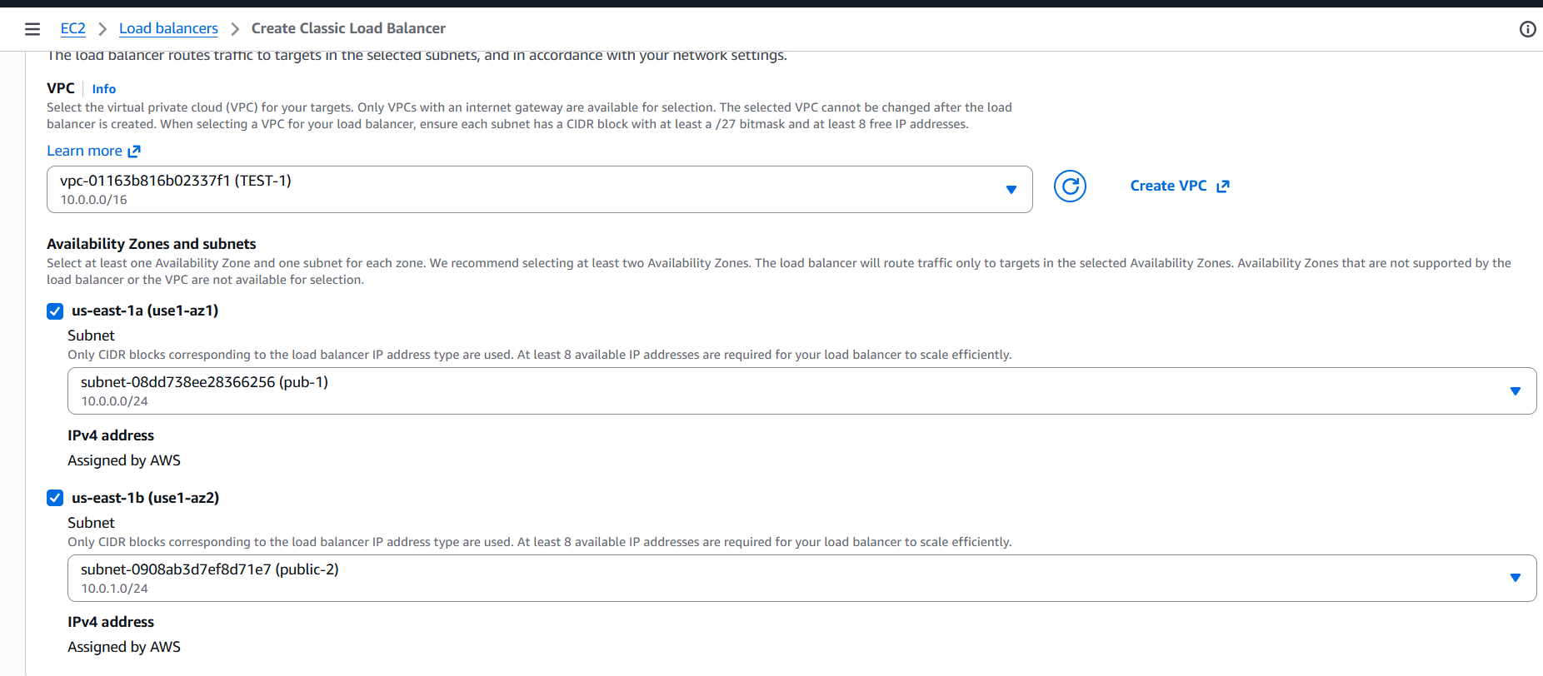
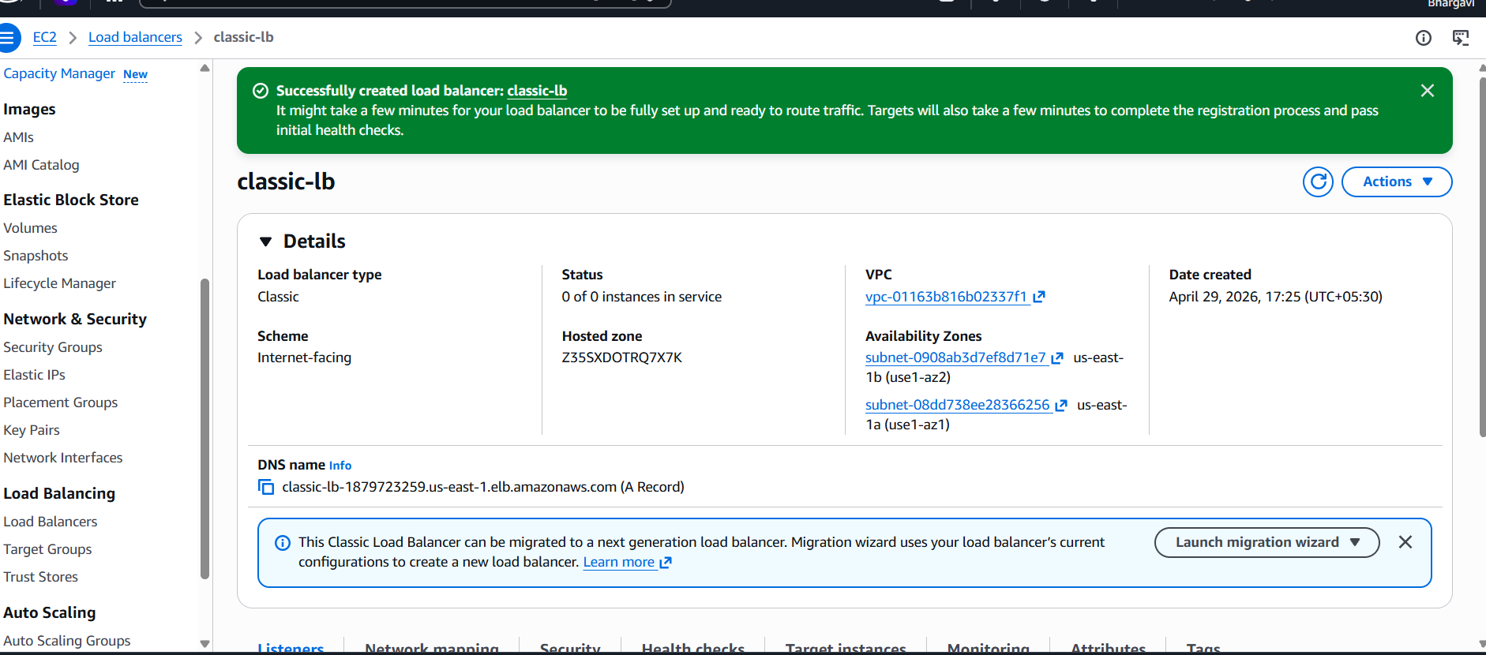


- Configure Application Load balancer.
AWS Console → EC2 Dashboard Load Balancing
-Click Load Balancers - Click Create Load Balancer--Application Load Balancer - Click Create-- -Your VPC Minimum 2 public subnets in different Availability Zones Under Listeners and routing:Click:
- Create target group Select both Apache EC2 instances…ClickInclude as pending below--Then:Click Create target group-- Create Load Balancer-- EC2 → Target Groups -- Select your target group --Open Targets tab-- Test the ALB-Go to:EC2 → Load Balancers Copy the DNS name
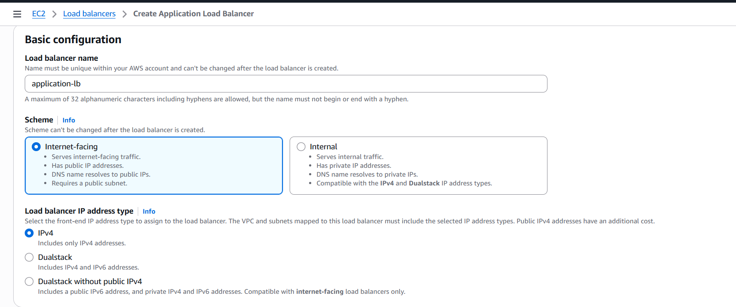
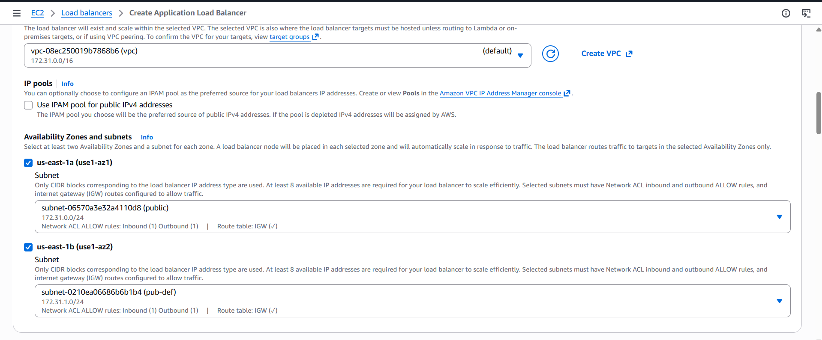
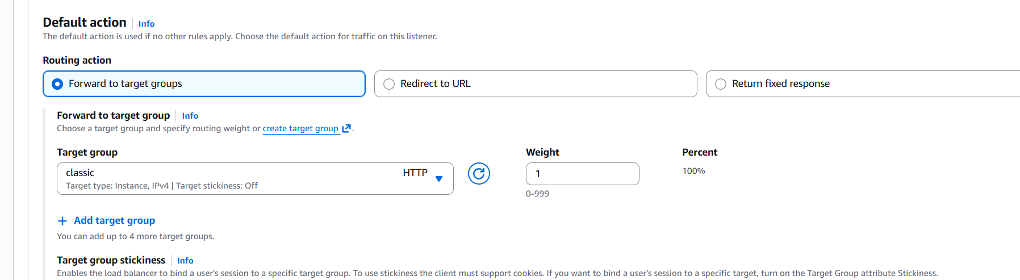
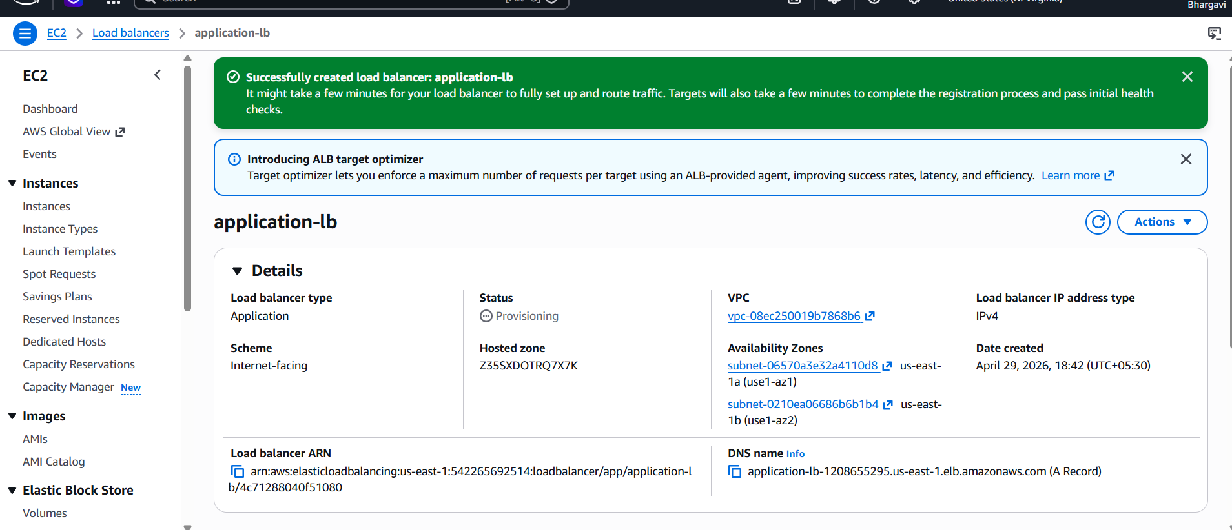
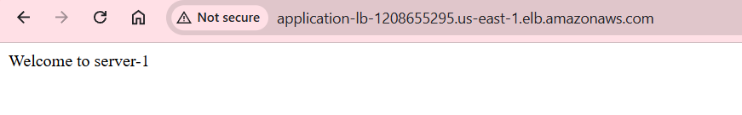
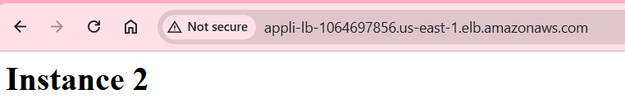
- Configure Network Load balancer.
• Open AWS Management Console
• Go to the EC2 Dashboard
- In the left menu:
- Select Load Balancers under Load Balancing
- Click Create Load Balancer - Network Load Balancer Click CreateSelect your VPCChoose at least two Availability ZonesSelect one public subnet from each Availability Zone Create target group--Select both EC2 instances-- Click Include as pending below-- Click Create target group-- Click Create Load Balancer Wait for AWS to provision the NLB
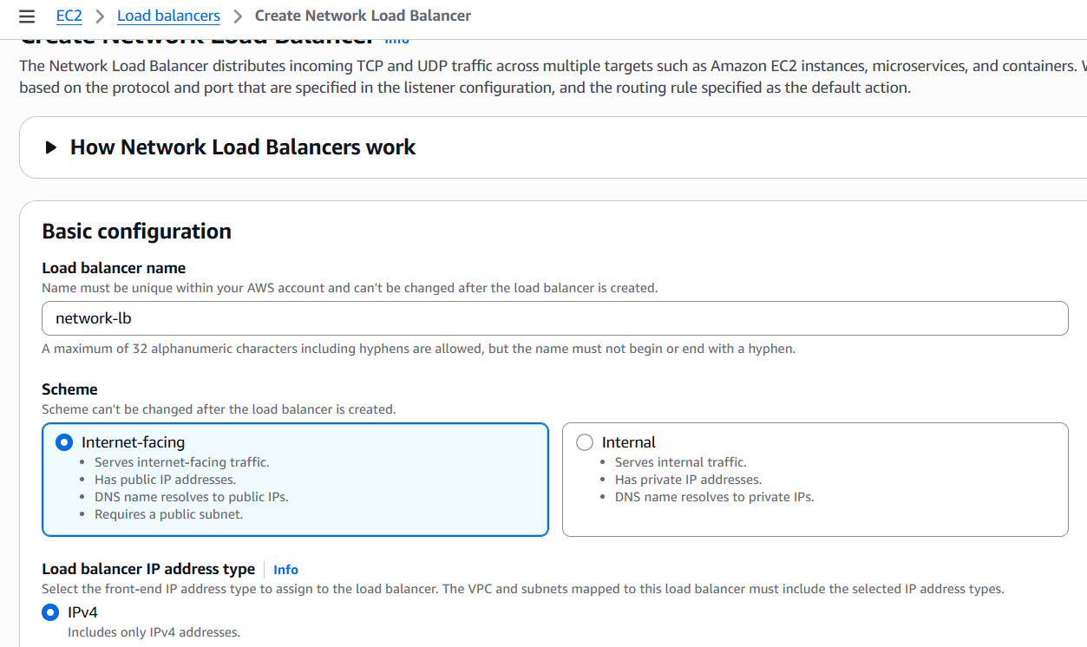
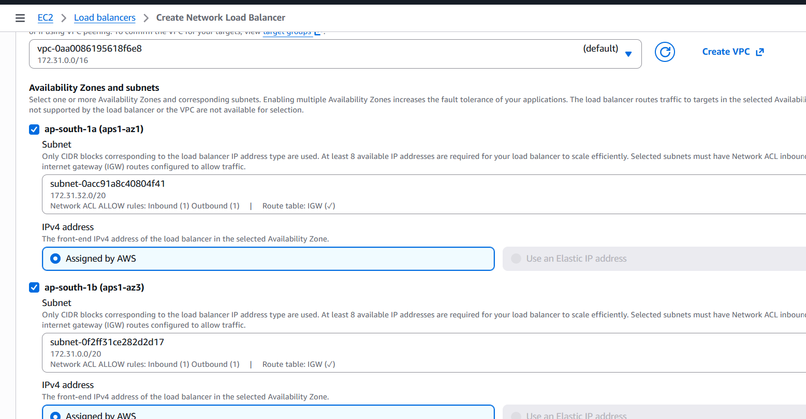
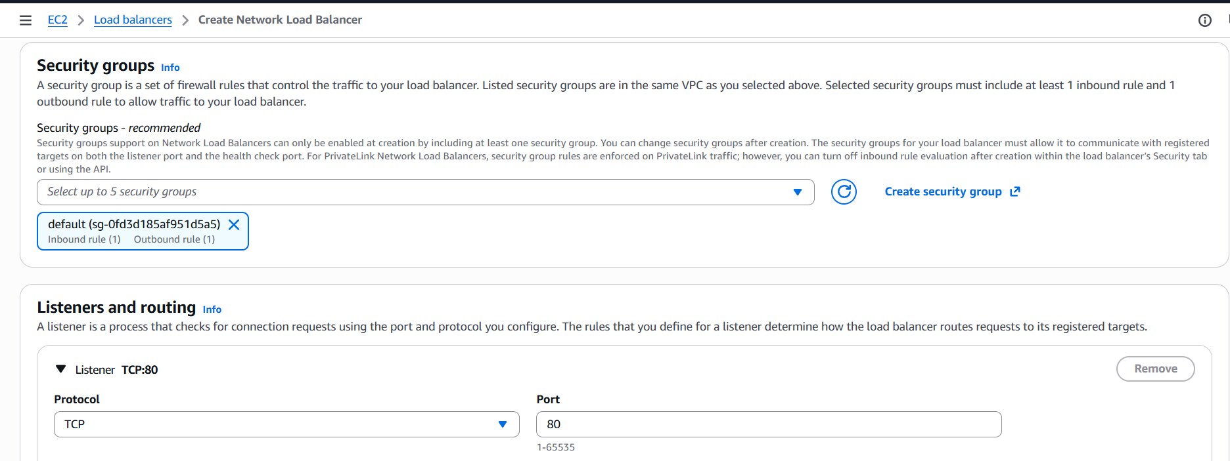
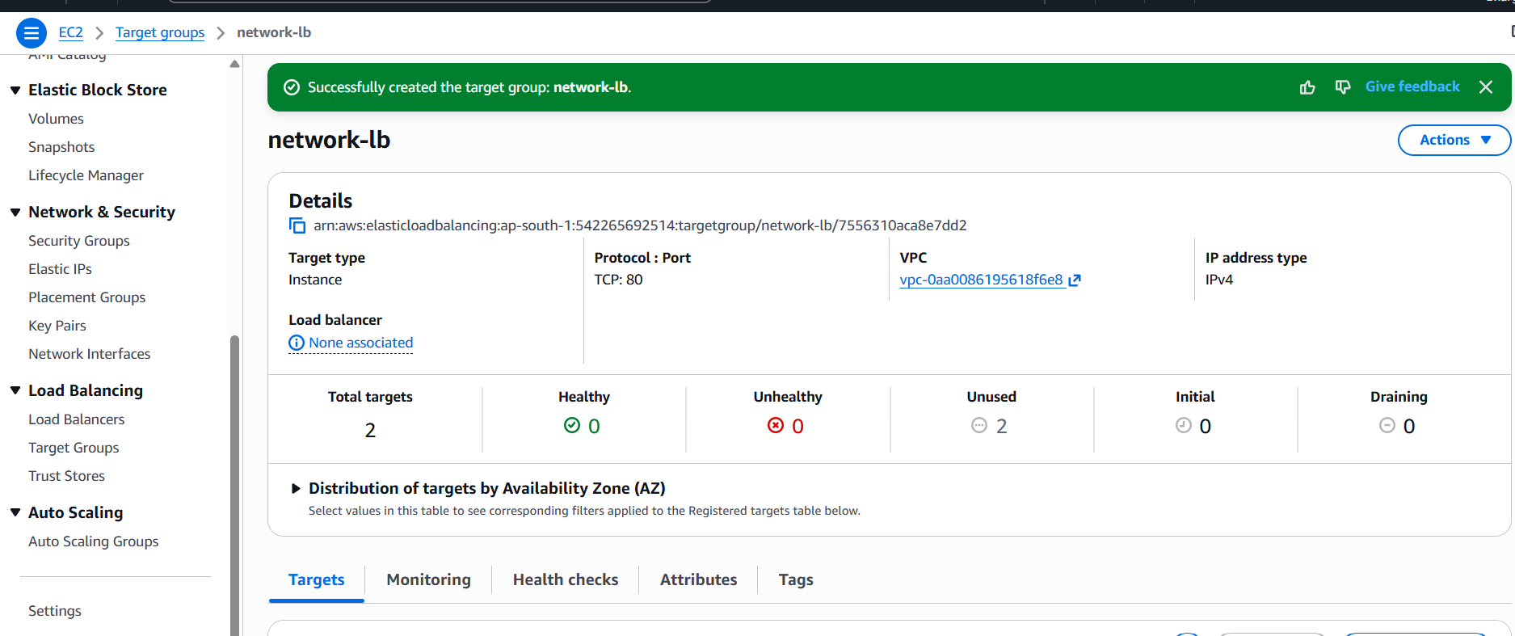
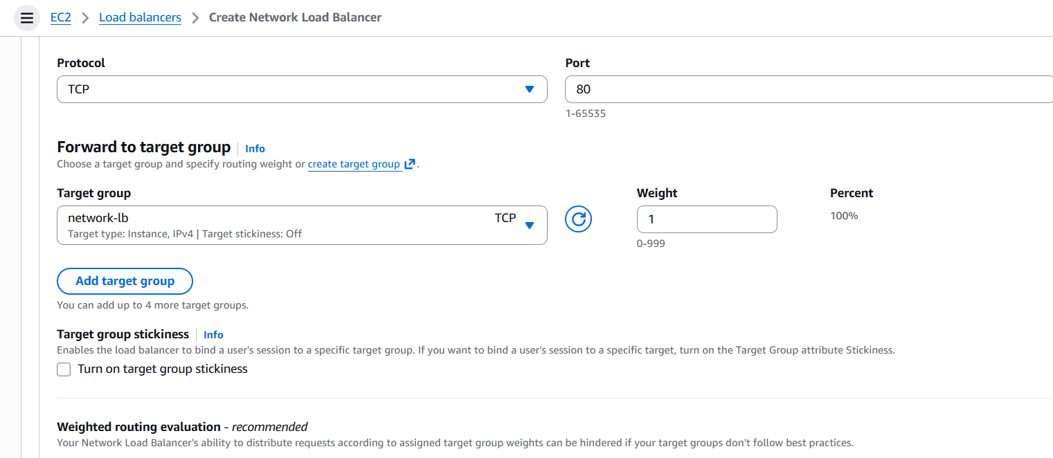
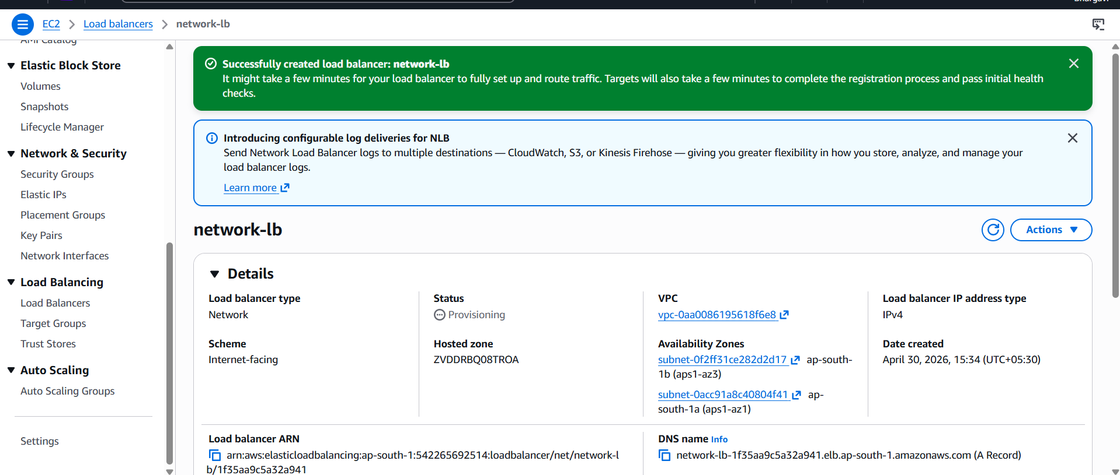
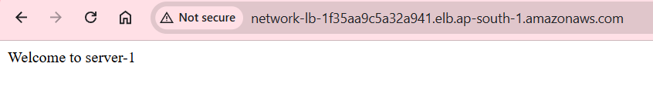
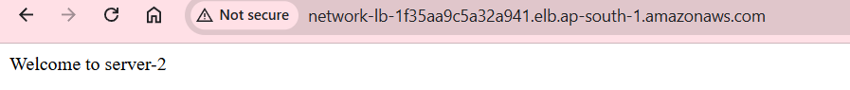
- Attach SSL for application load balancer.
• Login to AWS Management Console.
• Search for and open Amazon Web Services EC2 Dashboard
- In AWS Console, search for Certificate Manager. --Open AWS Certificate Manager. --Click Request a certificate. --Select:
- Request a public certificate I have Already one certificate then I use this certificate.

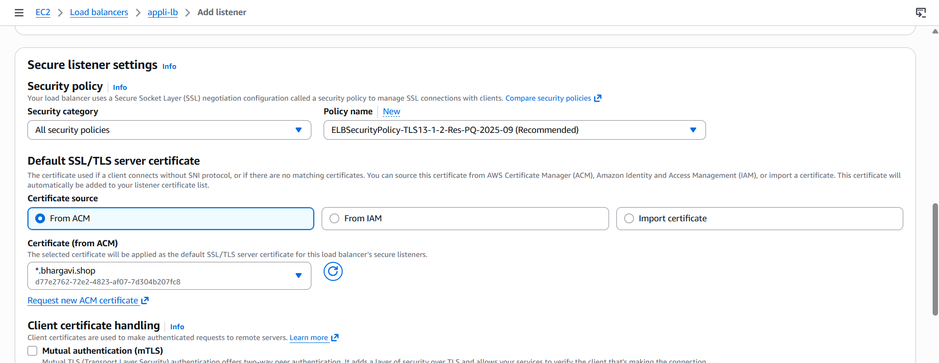
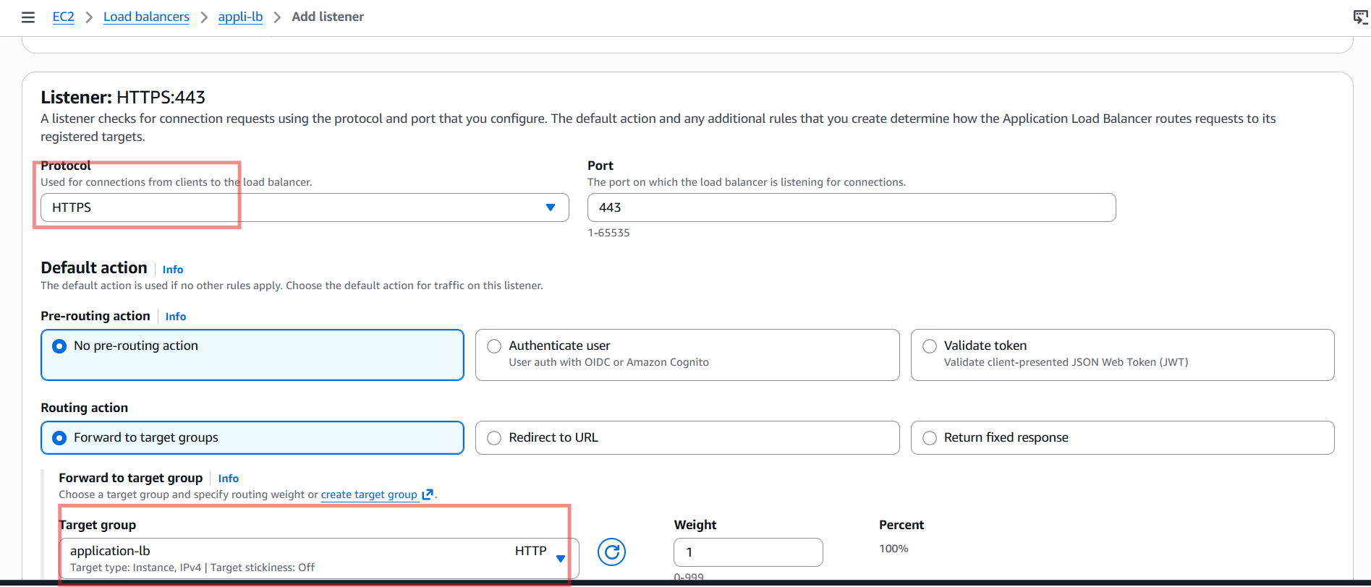
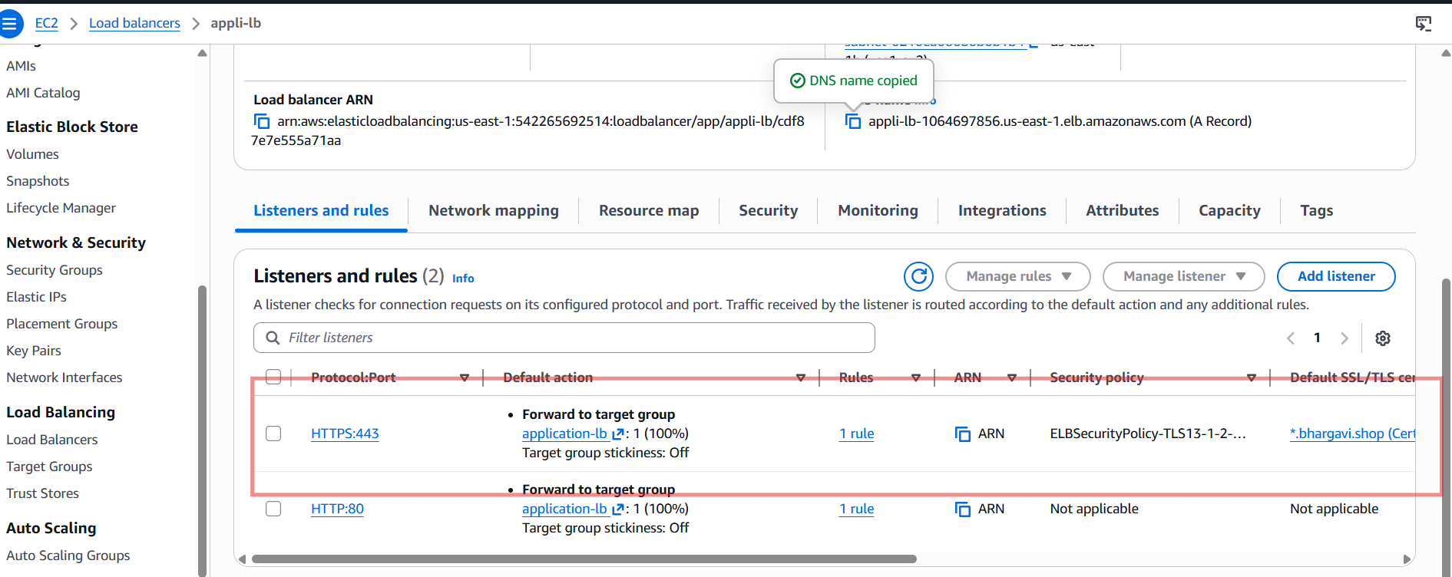
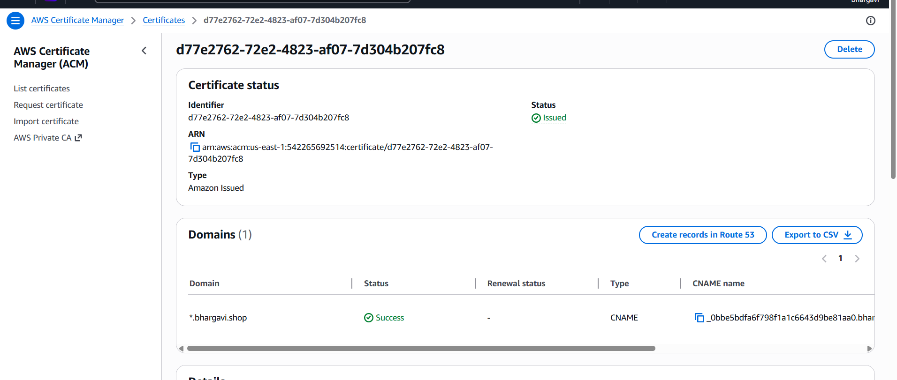

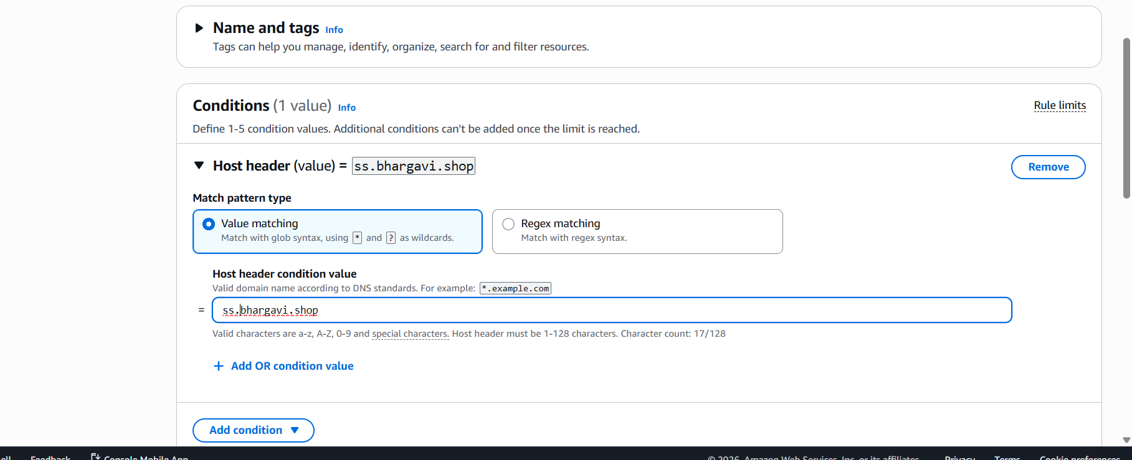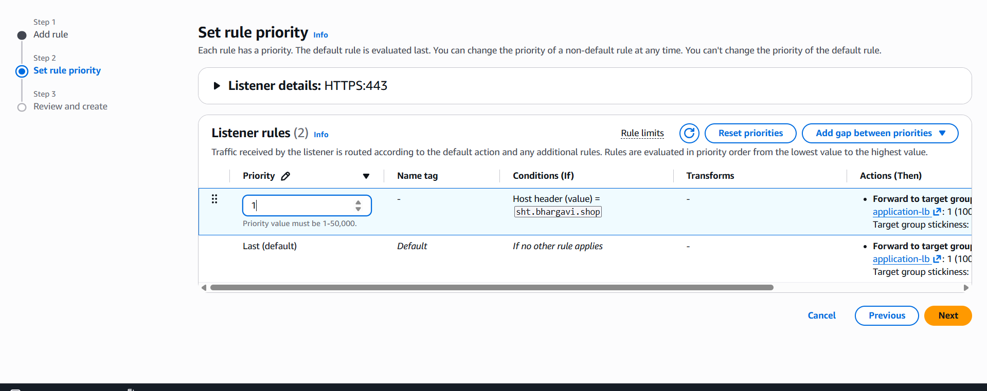
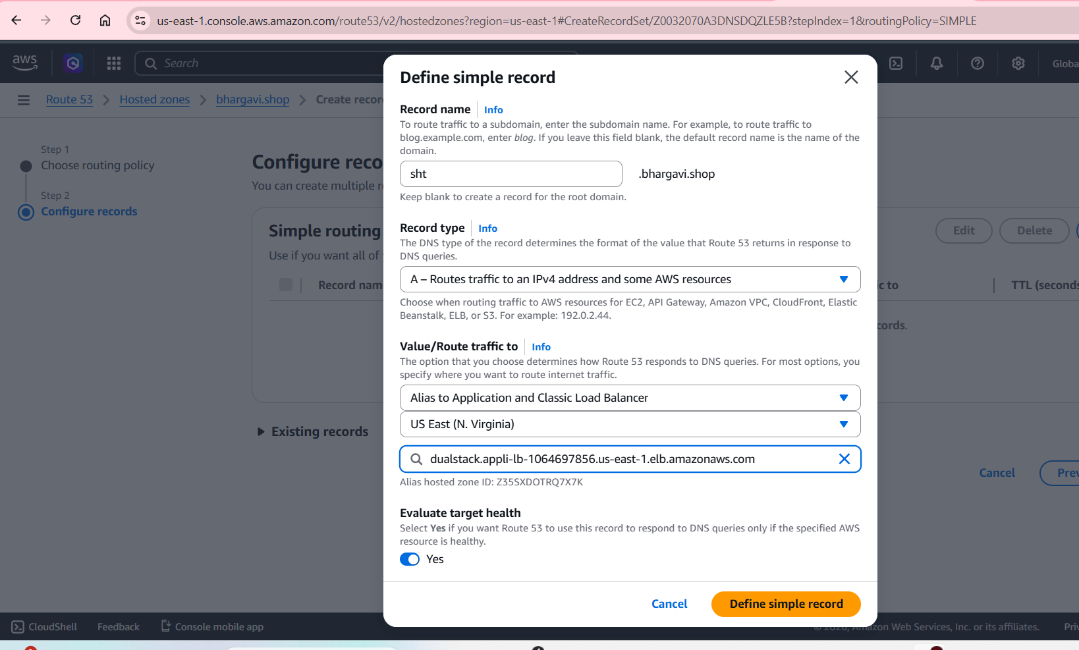
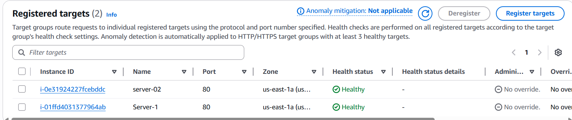
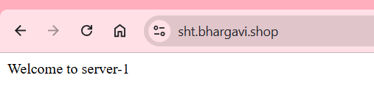

- Map Application load balancer to R53.
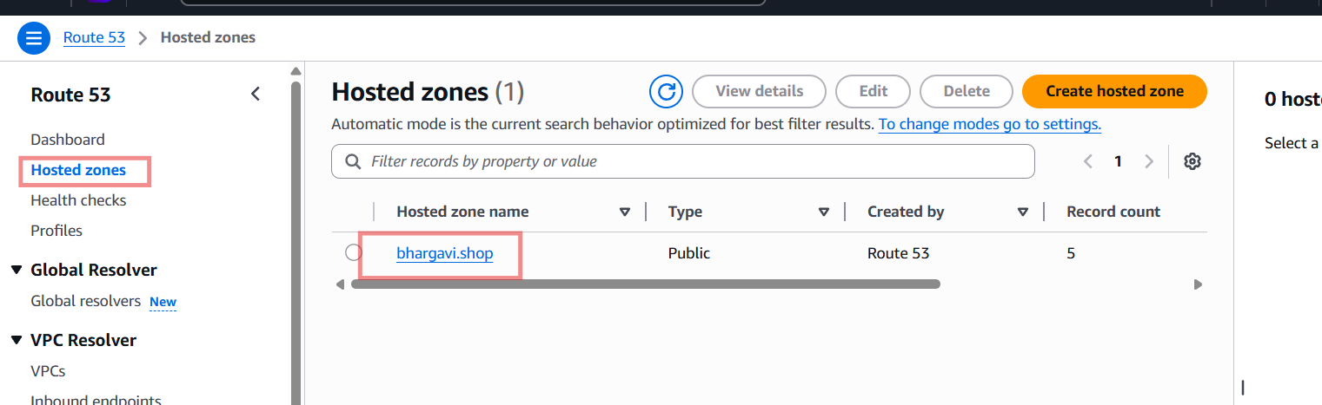
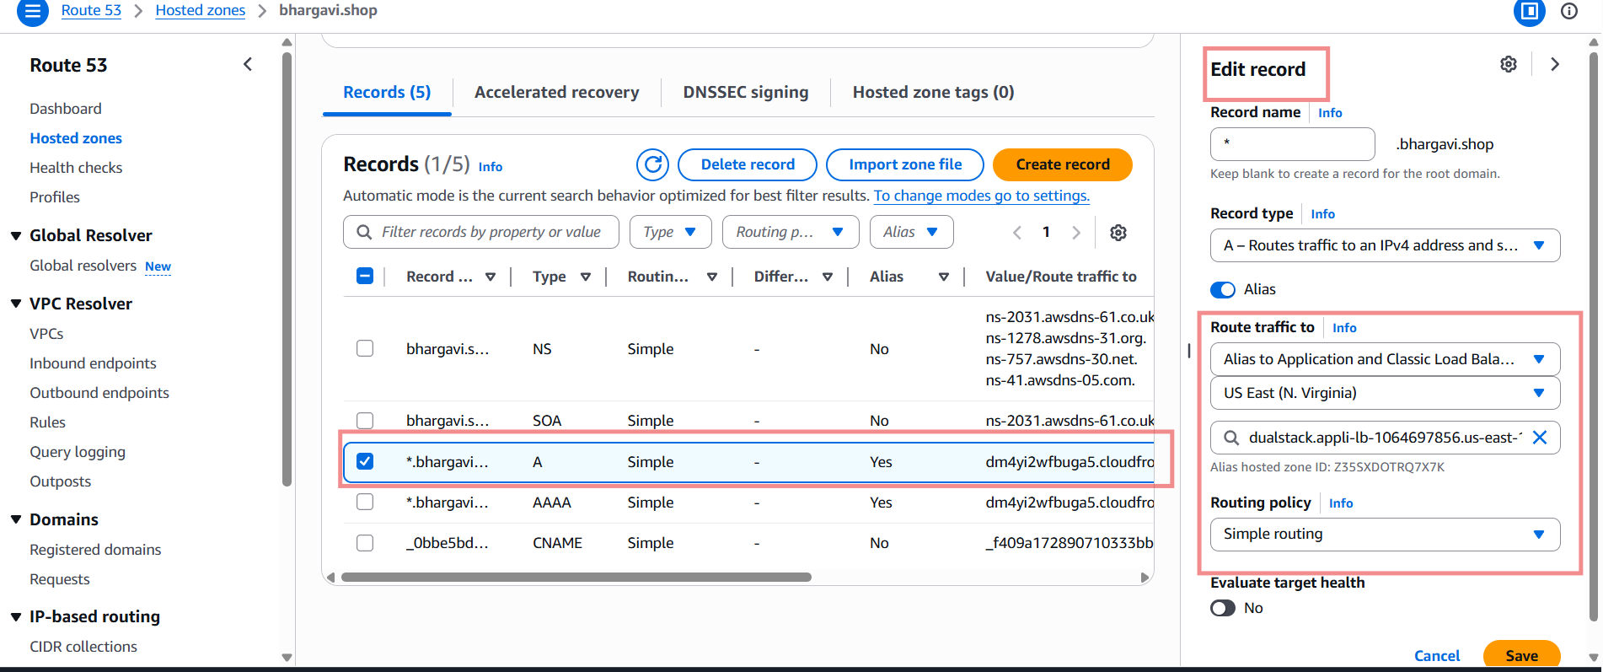
Now open domain

- Push the application load balancer logs to S3.
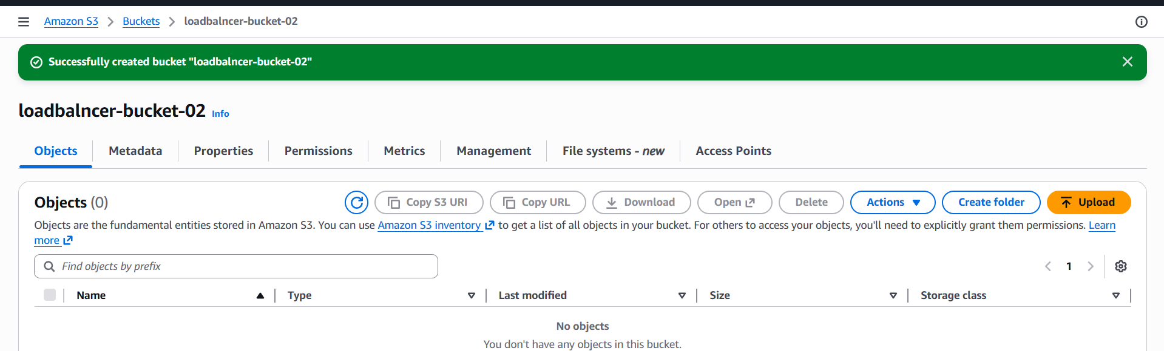
Amazon Web Services ConsoleSearch for S3. Open Amazon S3 Open your S3 bucket.

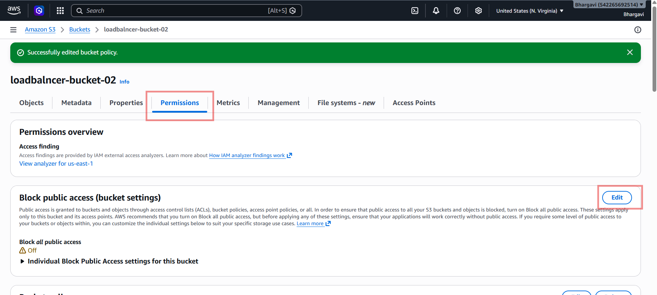
Go to:-PermissionsOpen:--Bucket Policy-Paste this policy

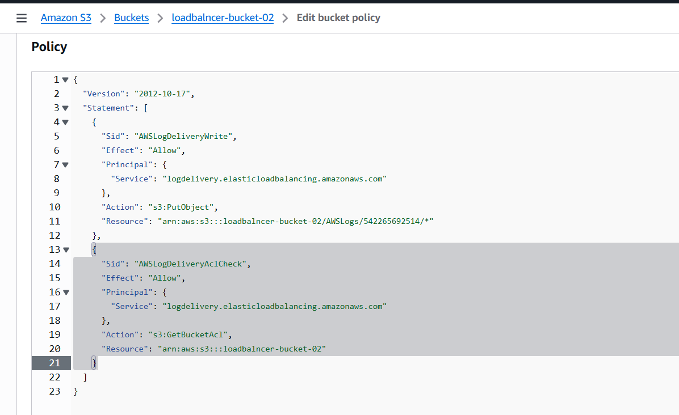
access logsenable and browse my bucket
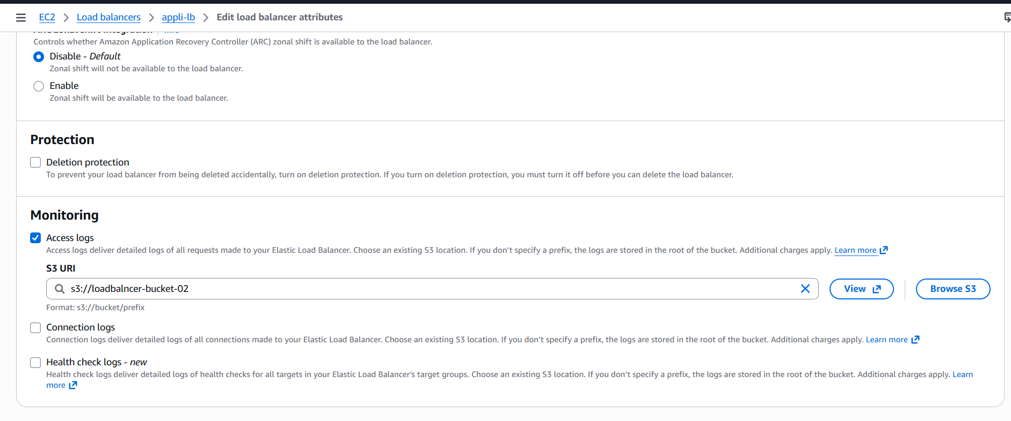
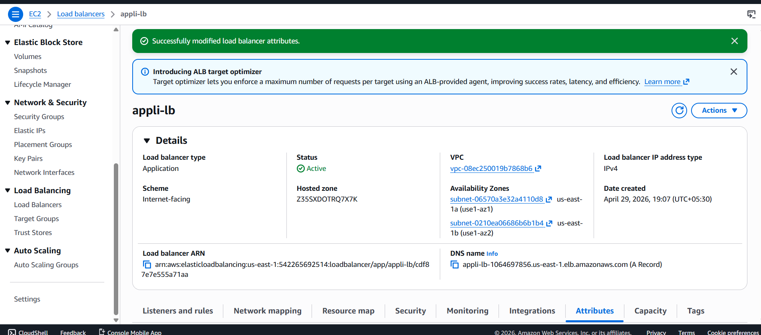
Now go to s3 bucket –see created logs
